Project based experimental learning program.

iRevolution: A Data-driven Exploration of Apple’s iPhone impact in India.

1.Introduction:

A data driven exploration of Apple’s iPhone impact in India. The world has changed as a consequences of the increasing use of smartphones, which have improved communication, connected people and revolutionized many business. With its main product, the iphone, capturing markets around the world, Apple Inc. has emerged as a prominent player among the top smartphone makers.

India, one of the economies with the greatest economic growth, has seen a tremendous increase in smartphones usage, making it an interesting market to study the effects of Apple’s iPhone. To know more about Apple’s iphone impact, Tableau is used for data extraction and analysing of datasets. Apple has a special chance to increase its market share and develop a significant presence in India thanks to the Country’s large population and rising smartphone adoption.

Each new iPhone model unveiling generates excitement and anticipation among Indian buyers. The project’s business needs call for data analysis and visualization in order to understand how Apple’s iPhone has affected India and other smartphones.

2. Problem Definition & Design Thinking:

Empathy Map:-

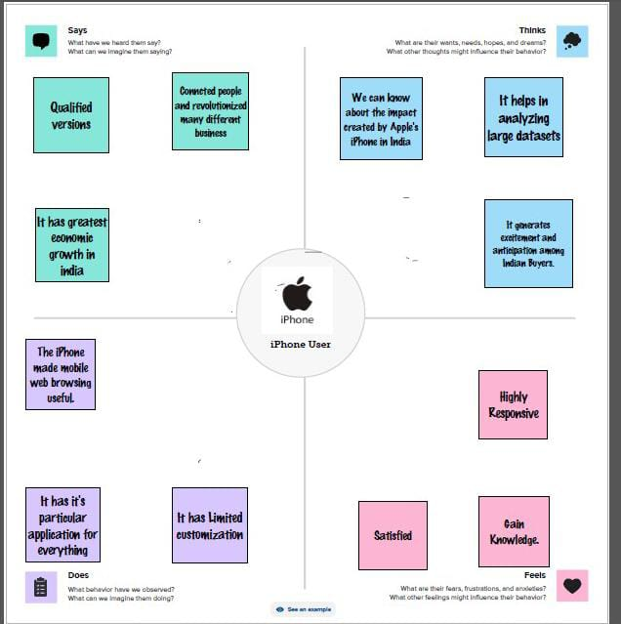

An empathy map describes how an iPhone user would feels, does, thinks and says about the impact of iphone in the world.

Ideation and Brainstorming Map:-

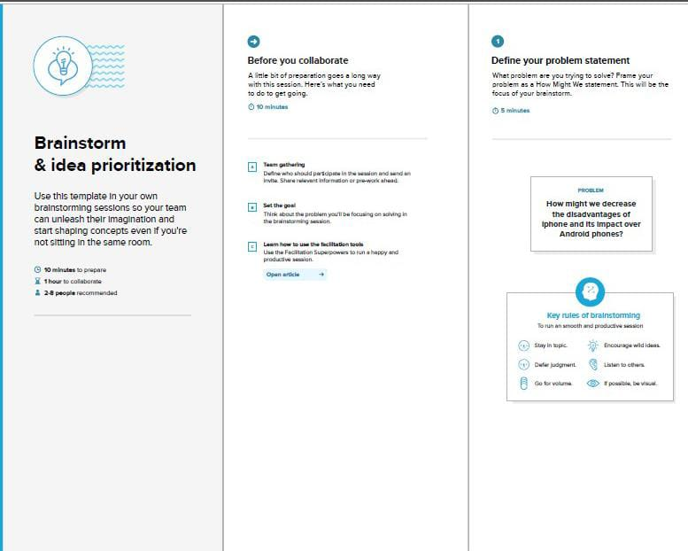

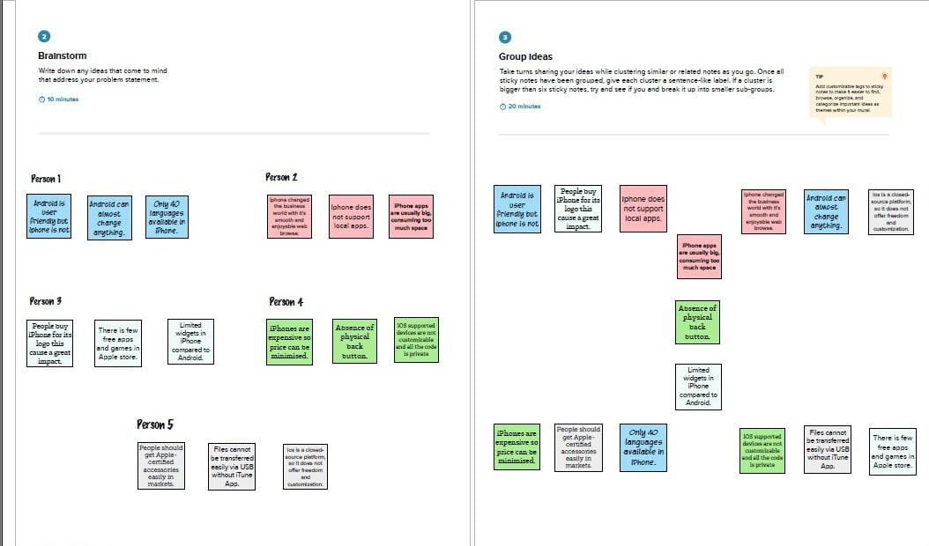

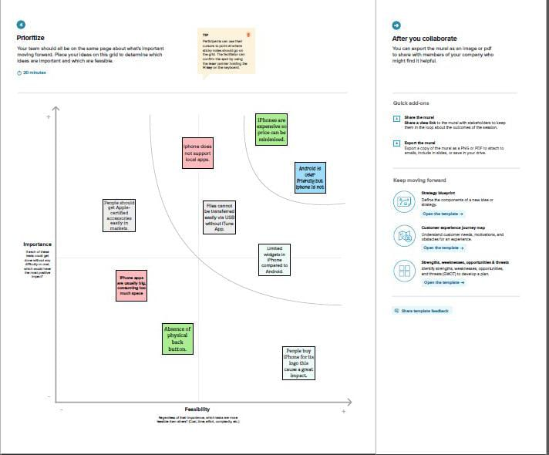

Ideation and Brainstorming gives the solution or idea to solve the problem related to iPhone impact in India. The ideas are prioritize according to the feasibility.

3. Results:

Dashboard 1&2:-

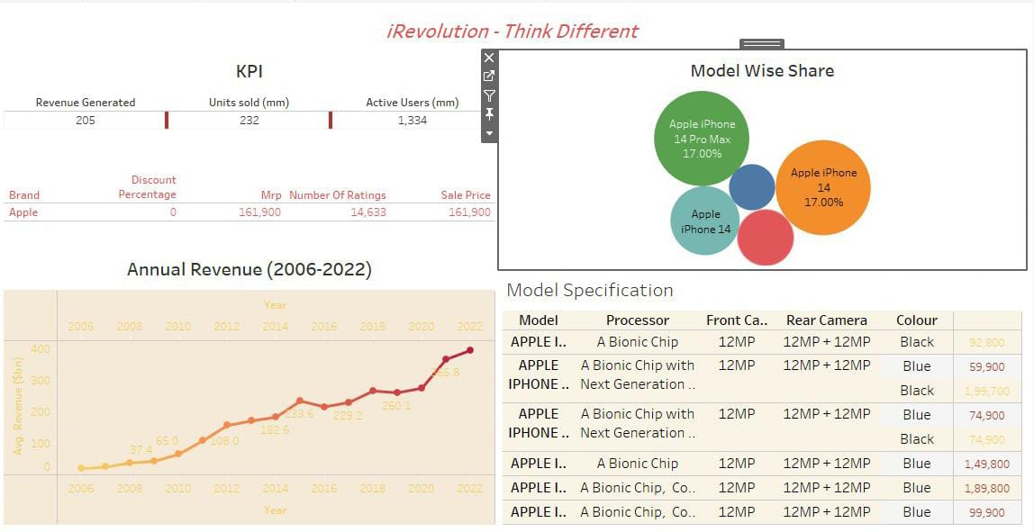

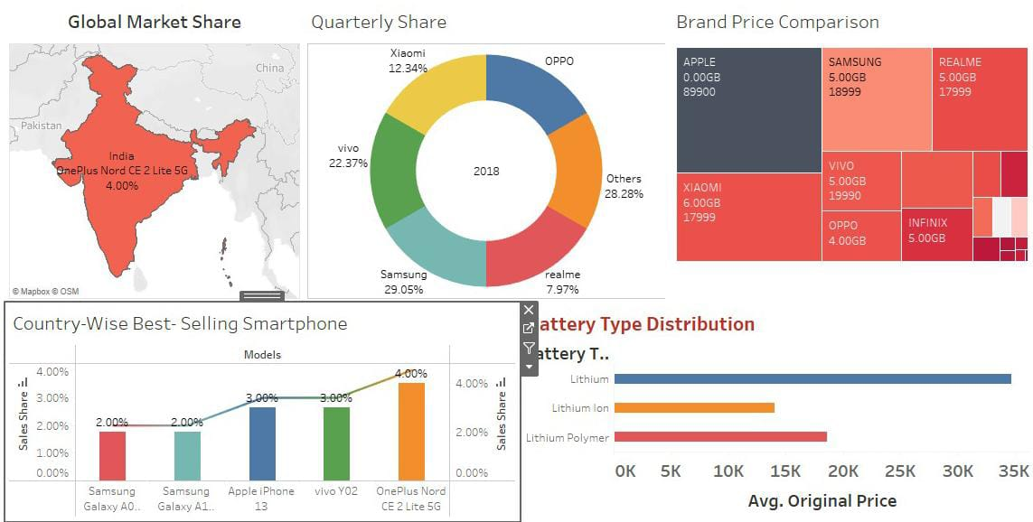

A dashboard is a graphical user interface that displays information and data in an organized, easy-to-read format. It is a collection of several views, letting you compare a variety of data simultaneously. For example, if you have a set of views that you review every day, you can create a dashboard that displays all the views at once, rather than navigate to separate worksheets.

Story:-

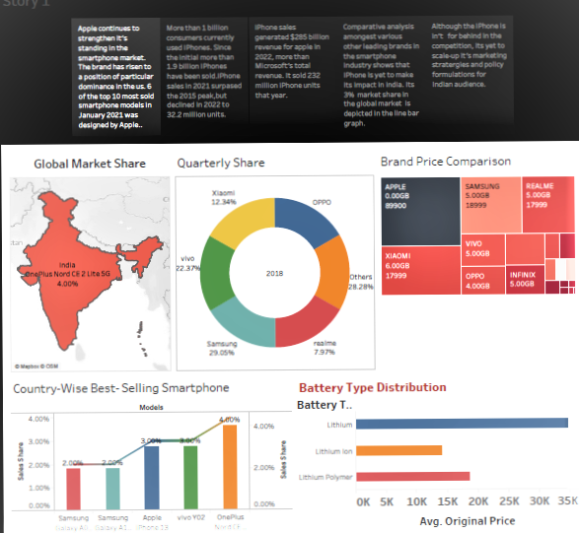

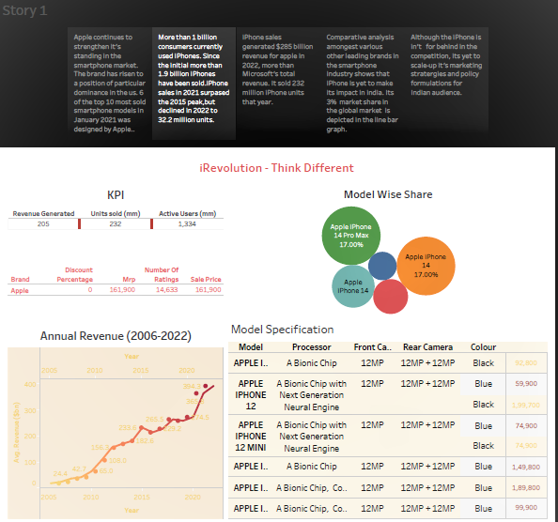

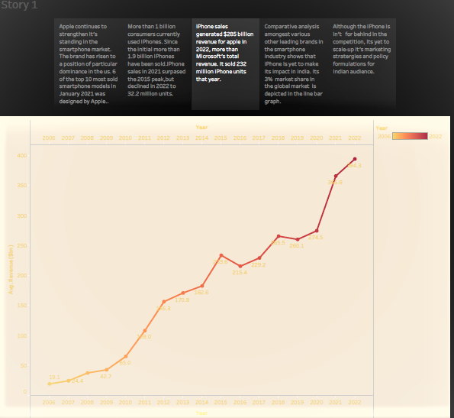

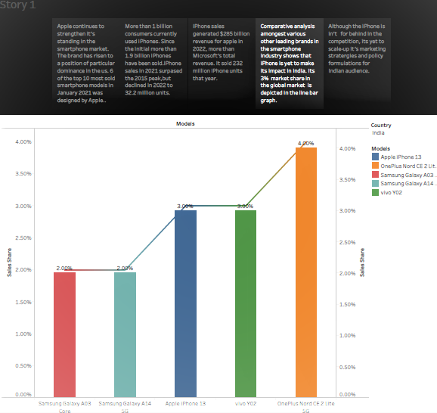

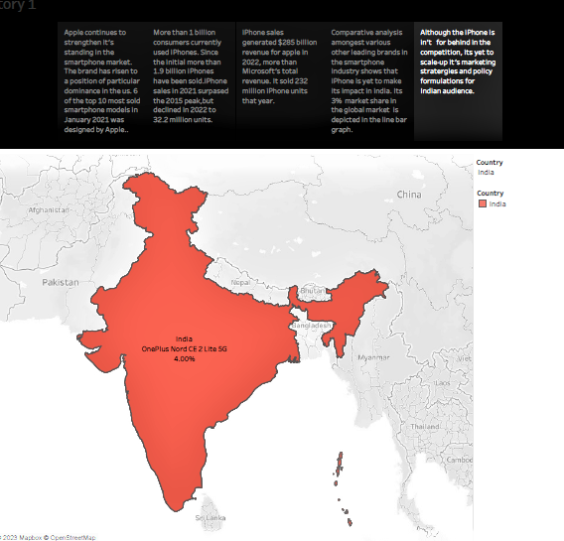

In Tableau, a **story** is a sequence of visualizations that work together to convey information. You can create stories to tell a data narrative, provide context, demonstrate how decisions relate to outcomes, or to simply make a compelling case.

A story is a sheet, so the methods you use to create, name, and manage worksheets and dashboards also apply to stories. At the same time, a story is also a collection of sheets, arranged in a sequence. Each individual sheet in a story is called a **story point**.

4. Advantages of iRevolution:

*User-Friendly Interface

*Apps Ecosystem

*Faster Processor

*iPhone Privileges

*Advanced Camera

*High-Quality Display

*No app crashes

*Good resale value

Disadvantages of iRevolution:

*Cost: The iPhone is one of the most expensive smartphones on the market.

*Non-Removable Battery: The iPhone's batteries are non-removable, which means that users cannot replace them.

*Limited Customization: One of the disadvantages of the iPhone is that it has limited customization options.

*Expensive Accessories.

*Limited widgets even after upgrades on iPhone.

5. Applications of iRevolution:

*Apple's computer was so revolutionary because it introduced this masses to a graphical user interface.

*The best interest of Apple is software Android's has not created a software platform or even a single application that could be considered world class.

*The iPhone is one of the two largest smartphone platforms in the world alongside Android, and is a large part of the luxury market.

*Touch screen was already there in the market, but it was not perfect until Apple did it.

* The iPhone has generated large profits for Apple, making it one of the world's most valuable publicly traded companies.

*Apple seems to recycling or taking ideas from many other stuffs in the market already and making it better.

*Apple seems to be idealistic because most people think there is a high correlation between performance and reward.

* Apple gave new era of technology in global market.

6. Conclusion:

The objective of this study is to obtain a thorough understanding of how Apple’s iphone would affect the Indian Market. Iphones are predicted to be the next disruptive market force in the field of technology. They have the potential to revolutionize around the world to recreate a new model.

Each new iphone model unveiling generates excitement and anticipation among Indian buyers. Tableau is used as the primary data visualization tool. Creating Dashboard, Story using Tableau and exploring Apple’s iphone impact. Tableau’s intuitive interface enables user’s to create interactive and visually appealing visualizations, charts and dashboard based on the analysed data. The project’s business needs call for data analysis and visualization in order to understand how Apple’s iPhone has affected India. Tableau visualizations should be interactive, understandable and educational so that stake holders can make data-driven decision and comprehend the impact of the iphone on the Indian market.

Policymakers and organisations can better manage the benefits and difficulties brought on by the expanding smartphone adoption by understanding the social impact. Research must focus on how Apple’s iphone has affected business in India. The economic effects of iphone uptake in the Indian market using data analytics and Tableau visualizations.

7. Future Scope:

Online surveys

Collect and Share data across your organization.

Global action plans

Collaborate on global and local action plans.

Projects governance

Centralize projects governance and management.

Strategic planning

Evaluate strategy implementations and planning.

Risks assessments

Deploy risk evaluations and reporting.

Validation workflow

Streamline your workflows across complex organizations.

Information repositories

Structure catalogues to share internally or externally.

Resources management

Organize resources across programs and projects